**\* Displaying Coordinates of the Image**

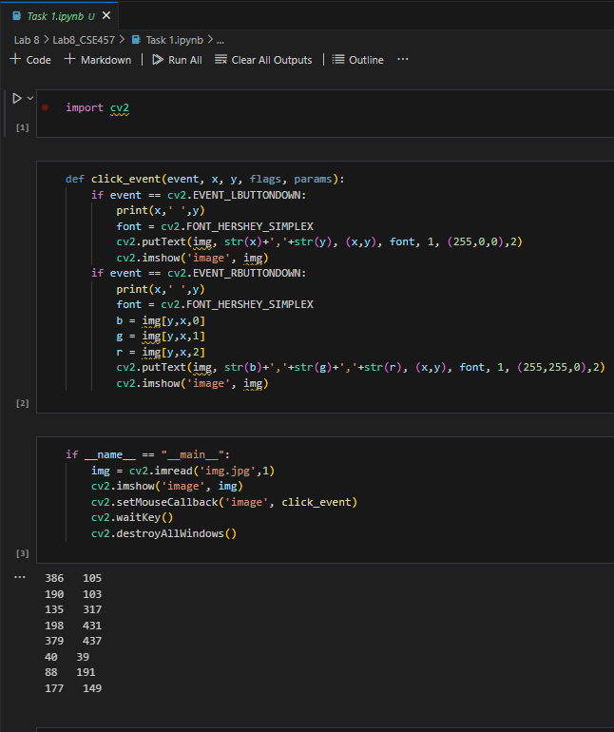

**\* High Dynamic Range of Images**

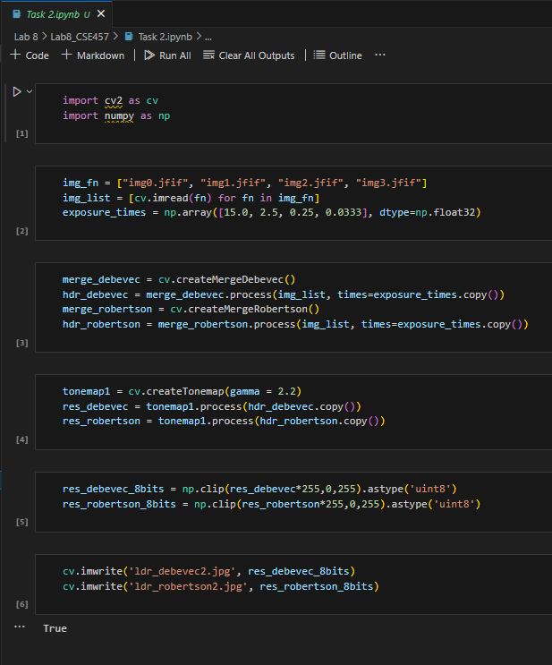

**\* CNN**

